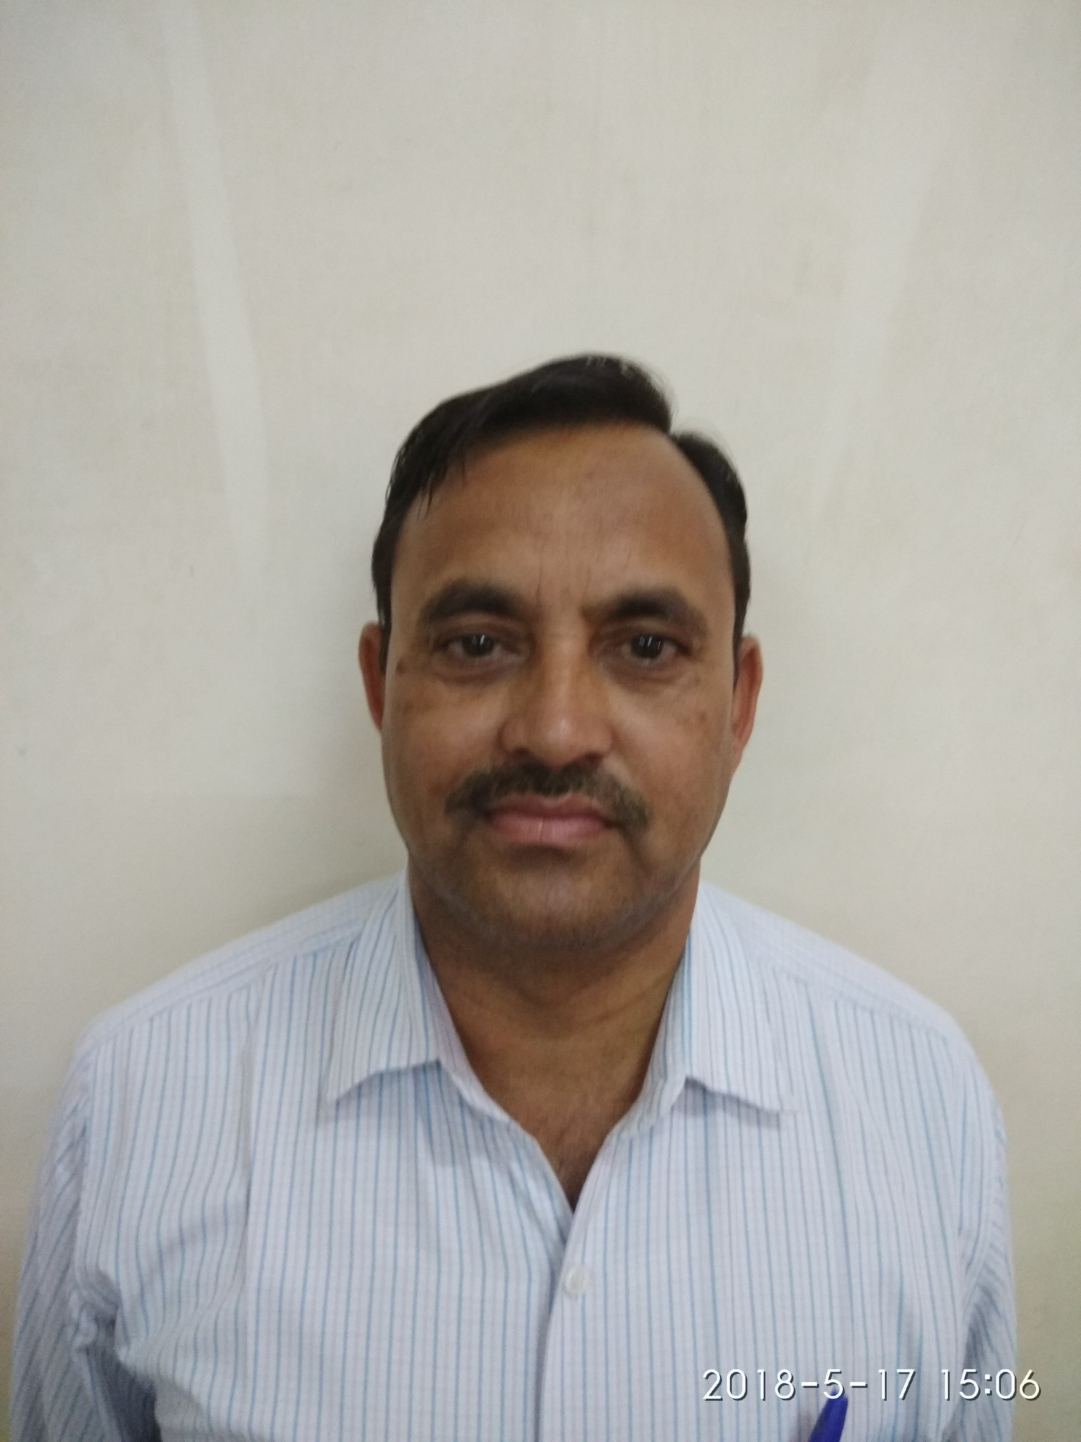
JECRC
Affix and Attest
passport
size photograph
JAIPUR

INDIVIDUAL TECHNICIAN DATA SHEET
Name of the Technical staff member | : | Hanuman Prasad Saini
Present Designation | : | Sr. Lab Instructor
Email Id: :hpsaini1970@gmail.com
Contact Details :9929979221

I. Particulars of Educational Qualification: (only completed)

Category | Name of the Degree | Specialization | Year of Passing | Name of the College | Name of the University
ITI | ITI | Fitter | 1990 | BGovt ITI, Tonk | BTER

II. Academic Experience : 16 Year

III. Industrial Experience : 1 YEAR

